The Himalayan Balsam Eradication Project at Pigeon Lake, Alberta

A noxious weed removal success story

In the mid-1990’s, a new plant appeared on the shoreline of Pigeon Lake. Each year it was continuing to advance along the shoreline and was becoming the predominant plant species. People loved its beautiful pink flowers and thought it was a welcome addition to the lake. But then it was found to be a noxious weed: the Himalayan Balsam. In 2009, an action plan for this plant was devised.
The plant is introduced to gardens through seed purchases and plant sharing. If left uncontrolled, the seeds can shoot out as far as ten feet when the seed pods explode. After seeds reached the lake, the Himalayan Balsam quickly spread along the shoreline through wave action and currents. By the time the eradication program started, the plant had spread roughly halfway around the lake over a distance of about 25 km. The plant also was found in some forested areas of the watershed as a direct result of the dumping of garden and beach rakings into the bush. This plant is classified as a prohibited noxious weed by the Alberta government, which meant the plant must be removed.
The initial eradication plan encouraged the lakeshore residents to pull and bag the plant as is the recommended practice for noxious weeds. But it soon became apparent that this strategy was not working. There were just far too many plants. Bagging of the plant was found to be slow and cumbersome. With thousands of plants going to seed, it was clear that a different method was required.
It was found that if the plant was pulled out by the roots, a very easy job because of the shallow root system, and the stem was broken, also an easy task as it snaps like a piece of crisp celery, the plant quickly died. This prevents advancement from the flower to seed stage and stops any re-rooting of the plant. If the plants are piled together, the bottom plants can maintain sufficient moisture to continue growing, but if dropped separately, they will die. So a new protocol was developed: Pick, Break and Drop. If done before the seed pods fully develop, this protocol has been found to be 100% successful in killing the plants.
For the first three years of the program, the goal was simply to destroy as many plants as possible. From the first of July, the shoreline on the lake was patrolled biweekly to remove the plants. It was found that these patrols were required until the end of September as new plants continue to germinate until the first frost of the season.
For plants with fully formed pods, the technique was adjusted slightly to collect any mature seeds and prevent them from forming new plants the following year. The top part of the plant, that part where the mature seed pods will have formed, is bent over and carefully placed inside a plastic bag. At this stage, any contact with the seed pod will cause it to explode and the seeds will “shoot.” Once inside the bag, the stem can easily be broken. This process is then repeated for any other seed clusters on the plant. After all the seed/flower clusters have been removed, the remaining plant can be picked, broken and dropped.
After six years, the shoreline is now free of this plant. The “Pick, Break and Drop” protocol proved to be entirely successful. Once the plant is removed from the ground, it quickly dies, as long as it is not dropped in wet soil or piled with other plants.

Reasons for using the Pick, Break and Drop protocol:
- It has been proven to be successful in destroying the Himalayan Balsam.
- It encourages the general public to participate in the program knowing that if they see a plant, they don’t need to have a bag for disposal.
- Removing weeds from a shoreline involves significant time climbing over wet and slippery rocks. It is much safer to patrol the shoreline without carrying a heavy bag of weeds.
- Dropping the plant where it was found growing ensures that the seeds will not be spread to another location from improper handling: leave the problem where the problem exists.
- This is the only practical method of eradicating this plant where it exists over a large area. Bagging the plant requires considerably more time and resources.

Recommendations for an Eradication Program
- One person must be responsible for the program to ensure that infested areas get patrolled routinely.
- Patrols must be conducted on a biweekly basis over the growing season until the first frost occurs. Otherwise, it will be difficult to gain headway as a few plants can produce a significant number of seeds.
- It is best to pull the plants before the seed pods develop, but if necessary, seed pods can be dealt with by bagging of the floral clusters and seed pods.
- An effective communication plan is needed to inform residents how to recognize and how to fight the Himalayan Balsam.
- It was soon found that a paid summer student was necessary to ensure the entire shoreline gets patrolled.
- For safety reasons, it was found walking in the water wearing hip waders was better than scrambling over wet, slippery rocks.

Why the Himalayan Balsam is a Noxious Weed
If this ornamental was kept controlled in a flower garden, it would be a welcome addition; however, the plant soon gets out of control because of its clever method of spreading its seeds. As the seed pod grows, the shell segments come under tension. When the pod is ripe and is disturbed, the shell segments roll back in an explosive manner and thereby propelling the seeds over a considerable distance. A garden can soon become overrun with the plant, and eventually it advances to the shoreline of a lake or stream.
With no natural control enemies, the Himalayan Balsam can quickly become the dominant species on a shoreline, displacing other beneficial species. In addition, it has been reported that because of the abundance of sweet nectar, bees and other insects will preferentially pollinate this plant to the detriment of other plants. The shoreline eventually becomes a monoculture, covered with only Himalayan Balsam. Because it does not start growing until July and disappears at the first of October, the shoreline remains bare and unprotected for most of the year. And the shallow root system provides little anchorage to inhibit shoreline erosion.
There are many places where the Himalayan Balsam has completely taken over the landscape. But with a carefully planned and executed program to eradicate this plant, the task can be successful.

How to Recognize the Himalayan Balsam
This plant is easy to recognize because of its distinctive pink flowers. The flower is shaped like a hood where the bees crawl inside for the nectar. The leaves grow in groups of three from the stem. The stem is hollow and is usually red but sometimes a light green. When the seed pods form, they look like “skinny peanuts”. The mature seeds small black granules.

How to Become Involved
Learn to identify the Himalayan Balsam, keep it out of your garden and wherever you find it, be sure to Pick, Break and Drop!

Thanks
The Pigeon Lake Himalayan Balsam eradication program was funded in part through the Watershed Stewardship Grant, a program of the Land Stewardship Centre financed by Alberta Environment and Parks.
Disclaimer: Land Stewardship Centre (LSC) is pleased to contribute to the delivery of this project through the Watershed Stewardship Grant Program, funded by Alberta Environment and Parks. LSC is committed to working with watershed stewardship groups to increase public awareness of the importance of the grassroots initiatives that are having a positive impact on watersheds and communities across Alberta. Opinions expressed in this website are those of Love the Lake and not necessarily LSC’s.
Share your stories or for further information, contact donald_d@telus.net
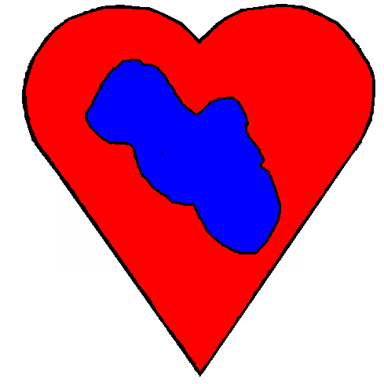

Love the Lake

